Tender Title: |  | RFT 05/2024 DRAINAGE SERVICES (SPEARWOOD) – Vernon Pl, Doolette St, Nym Pl & Falstaff Cr – Install only  Spearwood Ave – Supply and Install
Request ID: |  | 49779
Tender Description: |  | The City of Cockburn (the Principal) is seeking the services of a suitably qualified and experienced Contractor to undertake drainage installation services at the following locations in Spearwood, Western Australia.  - Vernon Pl, Doolette St, Nym Pl & Falstaff Cr Spearwood – Install only  This work is an upgrade to replace a pipeline with a larger size or a new service that did not exist previously. Generally, these improvements are undertaken to address localised flooding or to implement flood plain management plan recommendations.  - Spearwood Avenue Spearwood – Supply & Install  Supply and install underground storage system (Humes storm trap III & IV) in the median island to increase the capacity of an existing drainage sump.
Advert Approval: |  | Decision to Advertise: Chief Operations Officer  Decision Date: Tuesday, 9 April 2024
Closing Date and Time: |  | 2:00PM (AWST) Tuesday, 14 May 2024
Opening Date and Time: |  | 2:00PM (AWST) Tuesday, 14 May 2024
 | Tenderer’s Name:
1 | Aaro Group Pty Ltd
2 | DM Drainage & Construction Pty Ltd
3 | Dowsing Group Pty Ltd
4 | Wombat Civil Pty Ltd
5
6
7

Advertisement
Method 1: City of Cockburn | Method 2: Yammer
Method 3:  The Western Australian, Wednesday 17th April 2024 | Tender Awarded by:
Copy of Statewide Notice:  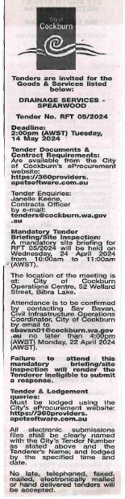 | Acting Director Infrastructure Services  Acting Director Corporate and System Services  Tuesday, 2 July 2024
 | Date of Council Meeting:
 | Not Applicable
Name of Successful Tenderer(s): | Dowsing Group Pty Ltd
Amount of Successful Tender(s): (ex GST) | $780,792 Ex GST

