Tender Title: |  | RFT 16/2023  Water Playground Testing and Maintenance
Request ID: |  | 47389
Tender Description: |  | The City of Cockburn (the Principal) is seeking a suitably qualified and experienced Contractor to conduct twice daily water testing and maintenance of its water playgrounds.
Advert Approval: |  | Decision to Advertise: Chief Operations Officer  Decision Date: Tuesday, 22 August 2023
Closing Date and Time: |  | 2:00PM (AWST) Thursday, 7 September 2023
Opening Date and Time: |  | 2:00PM (AWST) Thursday, 7 September 2023
 | Tenderer’s Name:
1 | Shenton Enterprise Pty Ltd
2 | The Royal Life Saving Society WA INC
3 | Poolwerx Corporation Pty Ltd
4 | Dalwood Family Trust, T/A DBS Drainage and Plumbing (Perth)
5
6
7
8
9
10

Advertisement
Method 1: City of Cockburn | Method 2: Yammer
Method 3:  The Western Australian,  Wednesday, 23rd August 2023 | Tender Awarded by:
Copy of Statewide Notice:  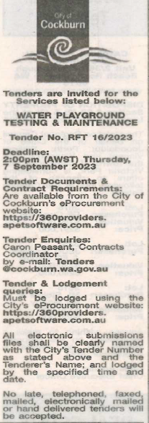 | Chief Operations Officer  Thursday, 5 October 2023
 | Date of Council Meeting:
 | Not applicable
Name of Successful Tenderer(s): | Shenton Enterprise Pty Ltd
Amount of Successful Tender(s): (ex GST) | $213,948

