Dieback Management Procedures

City of Cockburn Guidelines

# Table of Contents

Title 1

Table of Contents 2

Introduction 3

Hygiene Protocols 4

Cleaning and Sterilising the Vehicle, Footwear and other Equipment 5

Hygiene practices for vehicles and footwear 5

1.1 Cleaning Footwear 5

1.2 Guidelines for sterilising 5

Disinfectant Information 6

Signage 7

Managing drainage from infested areas 8

Access 9

More Information 11

References 11

Contact Us 12

Acknowledgement of Country

The Mayor, Councillors and staff of the City of Cockburn acknowledge the Whadjuk Nyungar people of Beeliar boodja as the traditional custodians of this land. We pay our respect to the Elders, past and present.

# Introduction

*Phytophthora cinnamomi* is a severe soil borne plant pathogen which attacks a wide range of plant species. It is known to cause dieback and death of susceptible plants in native forests, plantations, farms, nurseries, home gardens and food production. It can be a severe threat to plant producers to both the survival of seedlings and to the possibility of contamination of stock passing out of the nursery and into gardens, farms and forests.

*Phytophthora cinnamomi,* or more commonly known as Dieback, is a type of water mould that attacks the roots of the plant and causes them to rot. This kills the plant by preventing the uptake of water and nutrients. It spreads naturally by the movement of spores in water or by root-to-root contact. Dieback can spread at the rate of one metre each year on flat ground, though this is increased considerably by human activity.

A major source of the spread of the disease is via soil adhering to vehicles, machinery, tools and footwear for which adequate hygiene and wash-down procedures have not been taken.

Dieback is **not** killed by water. Therefore washing down of footwear, equipment or vehicles must use a disinfectant at a rate proven to be effective against the spores*.*

Widespread testing for Dieback has not been conducted on the Swan Coastal Plain and in only some parts of the City, therefore it must be assumed that sites may contain the disease and that vehicles and people can transport it to and from a site. Testing is usually restricted on a site by site basis so a precautionary approach should be taken.

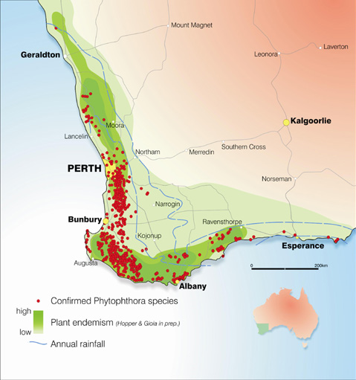

Image 1. Map of known Dieback sites across South West WA. Map courtesy Department Parks and Wildlife.

**Many sites have not been tested for Dieback so a precautionary approach must be adopted.**

# Hygiene Protocols

Dieback management focuses on hygiene practices that are critical for controlling both the introduction and spread of dieback. ‘Clean on entry’ (COE) is the primary principle. Hygiene is a series of practices that help prevent disease spread, especially through cleanliness.

It is the first line of defence against the spread of dieback because the pathogen can survive in BRM, soil, mulch, vegetative material and water. Sound hygiene practices will also potentially reduce the spread of other soil-borne pathogens, pests and weeds.

There are simple precautions that can be undertaken to prevent the spread of Dieback. These include:

* Reduce activities to fine weather, as this will reduce the risk of contaminated soil being transported from infected to non-infected areas on shoes or other means.
* Stay on designated driving tracks and walking trails.
* Do not remove plants or soil from the reserve to other areas. Also do not dump soil or plants into the reserve.

# Cleaning and Sterilising the Vehicle, Footwear and other Equipment

1. When entering a Dieback free site make sure the vehicle is clean on entry (CoE).
2. When exiting a Dieback infested site make sure the vehicle is cleaned down before departing using an appropriate disinfectant.
3. If unsure if Dieback is present, then clean vehicles on entry and exit.
4. If you have to move between infested and uninfected sites, once again cleaning is needed between each area.

# Hygiene practices for vehicles and footwear

* Removing all mud and soil from vehicles and footwear is imperative to reduce the spread.
* When cleaning down in the field select a hard, well drained surface, close to where you have been working.
* Try to remove the mud when it is dry, using a brush or stick. Pay attention to the tyres, mudflaps and soles of shoes.
* Spray with Phytoclean, Methylated Spirits or bleach to sterilise tyres, underneath of vehicle and the soles of footwear.
* Do not allow contaminated water to flow into the reserve/bushland area.

Cleaning Footwear

* Remove as much mud and soil with steel bristled brush.
* Use Methylated Spirits (70%) or bleach (1%) for sterilising footwear and hand tools. Allow to soak into soil on footwear.

Guidelines for sterilising*

* Sterilisation of equipment, footwear and vehicle tyres can be used to take an extra precaution.
* Spray methylated spirits (70%) on small hand tools and footwear covering all surfaces and allowing a few minutes for it to soak into all soil material.
* Spray 1% diluted bleach (sodium hypochlorite) onto equipment and footwear allowing a few minutes before rinsing the bleach off using water. Dilute bleach so that solution contains 1% active ingredient sodium hypochlorite. Be sure to follow any of the manufacturer’s safety instructions provided on the bleach container.
* Spray Phytoclean® can be used in footbaths, washdown facilities and during the cleaning of equipment. See the manufacturer’s details for directions.

*(Management of *Phytophthora* Dieback in Extractive Industries, Dieback Working Group,2004)

# Disinfectant Information

Table 1 below lists a number of disinfectants and their rates that have proven to be effective disinfectants with regards to controlling Dieback.

1. Phytoclean specialised disinfectant cleaner & sanitiser

The effective general purpose micro biocide and algaecide.

PHYTOCLEAN® is a disinfectant cleaner and sanitiser, specially formulated for the control of *Phytophthora cinnamomi*, and similar organisms, in the agriculture, horticultural, plantation, construction and mining industries.

1. Methylated Spirits- a 70% solution can be applied to disinfect vehicles, equipment and footwear.
2. Bleach(Sodium hypochlorite) 1% solution

Table 1. Disinfectants effective against dieback and application rates

| Disinfectant | Application examples | Application rate |
| --- | --- | --- |
| Methylated spirit | After complete removal of soil, spray small items such as footwear or tools liberally | 70 per cent in water |
| Phytoclean® (sold as 10 per cent active ingredient) | Step into footbath (footwear), or dip small equipment/tools after removal of soil | 100mL in 1L water |
| Spray machinery/vehicles after complete removal of soil | 200mL in 10L water |

Sourced from: Department of Biodiversity, Conservation and Attractions (2020). Phytophthora Dieback Management Manual, October 2020, Department of Biodiversity, Conservation and Attractions, Perth



# Signage

In several reserves within the City, reserves have been tested for Dieback and where found signage appears on entry gates. This signage indicates if Dieback is present, not present or if caution needs to be taken. The City has also installed several boot cleaning stations for the public within specific reserves.

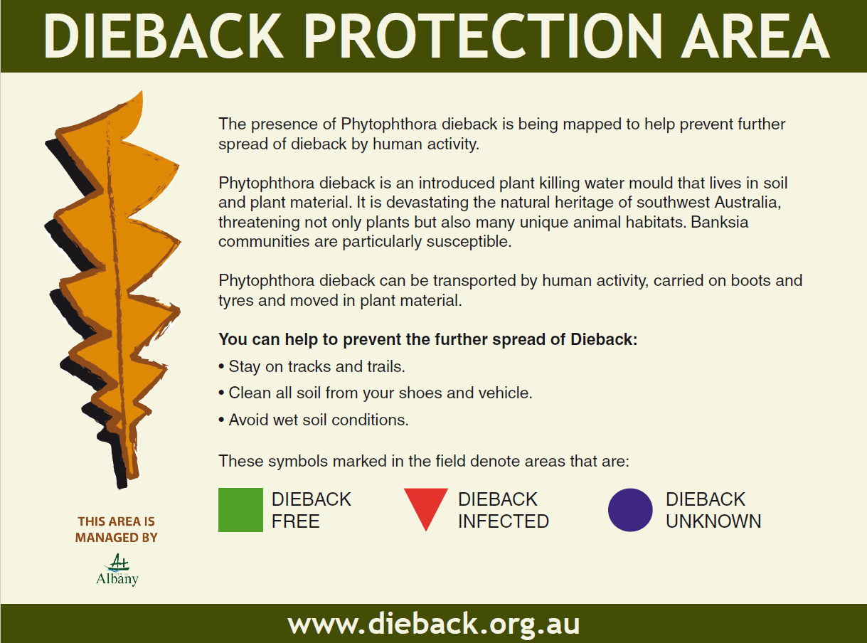

# Managing drainage from infested areas

Water draining from roads likely to be infested and drainage from infested areas should be directed away from uninfected areas or taken to the lowest possible point in the landscape before being directed into areas of native vegetation.

Water binding during road works should be kept to a level where run-off into adjacent uninfected areas does not occur. The early installation of correctly designed table drains will ensure that un-seasonal rainfall does not flush material from the road building operation across adjoining areas of susceptible native vegetation (CALM 2004). Refer below for a range of management actions that can be taken in response to water draining.

Table 2. Management actions for water drainage in infested areas.

| Action Description | Rationale |
| --- | --- |
| Training | Train all staff about *Phytophthora* Dieback, its impact, management, and the value of *Phytophthora* Dieback free materials. |
| Signage | Inform personnel entering the site that it is free of Phytophthora Dieback and the need to washdown any equipment/vehicles/footwear that enter the quarantined area. |
| Wash-down facility | Clean-on-entry. All vehicles should be washed down prior to entering the site. Quarry workers should wash footwear prior to entry on the site. |
| Quarantine area | Restrictive fencing surrounding the site and provision of parking areas outside the site. Establish a split phase operation to separate loading and excavation areas. Limestone makes an ideal material for use in construction of the loading area due to its high pH being very suppressive of *Phytophthora* Dieback. |
| Containment of surface water on-site | Surface and sub-surface water are an efficient means for the spread of *Phytophthora* Dieback. To ensure the pathogen would not be spread around the site if accidentally introduced it is important to contain any surface water. Ensure drainage does not enter the site from surrounding areas. |
| Water management | Ideally water used on site (e.g. to reduce dust) should be either from main’s supply or a deep bore. If the water is from a dam or creek, it is essential to sterilize the water prior to its use. |
| Rehabilitation using Phytophthora Dieback free materials | Only bring in certified *Phytophthora* Dieback free materials (e.g., soil, mulch, and compost.) Purchase plants from accredited nurseries. Consider direct seeding rather than planting seedlings. |
| Customer notification | Advise customers that the material is free of *Phytophthora* Dieback. |
| Regular testing of the stockpile and extraction area | Regular testing can be used as evidence that the dieback-free status of the quarry and its extracted materials is maintained. |

Sourced from: Management of ***Phytophthora* Dieback** in Extractive Industries, Dieback Working Group.

# Access

Any access to a site provides the opportunity to introduce dieback, and the more frequent the access the higher the probability. Frequent and repeated access dislodges leaf litter exposing the soil, which increases the chances that soil will be picked up by tracked machinery, tyres or footwear and inadvertently moved. Table 3 below provides a guide to reduce the risk of spreading Dieback during movement events.

Table 3. Options to reduce dieback risk associated with access

| Action | Description |
| --- | --- |
| Road/track maintenance | * When grading a road, work to mapped dieback occurrence boundaries (preferred). If the road is not able to be interpreted, only push material downslope. * Frequently check and fill in potholes and puddles using uninfested / low risk material. |
| Road/track construction | Where practicable construct roads/tracks:   * To remain within the infested or unprotectable categories. * Low in profile such as parallel to a riparian zone. * With a rumble strip at the entry to protectable areas so loose soil falls away prior to entry. * With high crown for better drainage. * With deep roadside drains and coarse material to minimize erosion. * With off-shoot drains preferentially located towards the base of the slope. * That are sealed (if viable). |
| Green bridge | Construct a green bridge over an infested or unprotectable portion of road/track or over an area that is likely to become boggy with frequent access. |
| Plan route | * Use sealed or well-formed roads. * Avoid muddy puddles and creek crossings. * Have a contingency plan for worst case scenarios (i.e. getting bogged). * Schedule access as far as possible during dry conditions. * Communicate planned route to staff and contactors with maps and / or signs. |
| Restrict access | * Conduct the activity in split-phase. * Establish Clean on Entry (COE) points(s) to restrict access to carriers that meet cleandown standards. * Control access using gates, fencing (full or partial) or barriers such as mounding, concrete blocks, boulders, logs or trenching. * Close access permanently using gates and / or ripping / rehabilitating first 100m of track. * Quarantine an area. |

Sourced from: Department of Biodiversity, Conservation and Attractions (2020). Phytophthora Dieback Management Manual, October 2020, Department of Biodiversity, Conservation and Attractions, Perth

# More Information

Dieback Working Group

<https://www.dwg.org.au/>

Department of Parks and Wildlife

<https://www.dpaw.wa.gov.au/management/pests-diseases/phytophthora-dieback>

# References

Conservation and Land Management 2004; Best practice guidelines for the management of *Phytophthora cinnamomi*

Dieback Working Group, Management of ***Phytophthora* Dieback** in Extractive Industries <https://www.dwg.org.au/images/dieback_publications/ExtractiveIndustry_DiebackGuidelines.pdf>

Department of Biodiversity, Conservation and Attractions (2020). Phytophthora Dieback Management Manual, October 2020, Department of Biodiversity, Conservation and Attractions, Perth <https://www.dpaw.wa.gov.au/images/documents/conservation-management/pests-diseases/disease-risk-areas/DBCA%20PDMM%20v1.2%20October%202020.pdf>

# Contact Us

**City of Cockburn**

9 Coleville Crescent, Spearwood WA 6193

PO Box 1215, Bibra Lake DC Western Australia 6965

Telephone: 08 9411 3444 Fax: 08 9411 3333

Email: [customer@cockburn.wa.gov.au](mailto:customer@cockburn.wa.gov.au)

[City of Cockburn website: cockburn.gov.wa.au](http://www.cockburn.gov.wa.au)

Socila media logos: Facebook, Twitter, Instagram and YouTube.