Tender Title: |  | RFT 16/2025 Leisure Management Software – Cockburn Arc & Seniors Centre
Request ID: |  | 70183
Tender Description: |  | The tender is to select a suitable provider of a Leisure Management, that is a software as a service (SaaS) solution, not hosted but delivered via web browser, that is suitable for managing memberships, facility and class bookings, supports payments, provide automated reporting and analytics, communications and marketing, mobile and member portals, access controls and security, plus is able to support the normal daily activities of staff (the User), with point of sale and stock control. The proposed contract duration is for a period of five (5) years from the date of award; with City instigated options to extend the period for one (1) subsequent year period and, to a maximum of ten 10) years.
Advert Approval: |  | Decision to Advertise: Director Community and Place  Decision Date: Wednesday, 9 July 2025
Closing Date and Time: |  | 2:00PM (AWST) Tuesday, 29 July 2025
Opening Date and Time: |  | 2:00PM (AWST) Tuesday, 29 July 2025
 | Tenderer’s Name:
1 | Perfect Gym Solutions Pty Ltd

Advertisement
Method 1: City of Cockburn Website | Method 2: City of Cockburn Public Libraries Notice Boards
Method 3:  The Western Australian, Saturday 12 July 2025 | Tender Awarded by:
Copy of Statewide Notice:  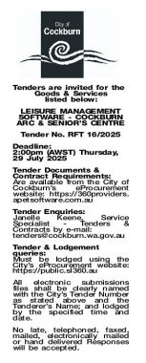 | A/Director Community and Place  A/Director Corporate and System Services  Monday, 1 September 2025
 | Date of Council Meeting:
 | N/A
Name of Successful Tenderer(s): | Perfect Gym Solutions Pty Ltd
Amount of Successful Tender(s): (ex GST) | $882,034.50

